G55B Specification
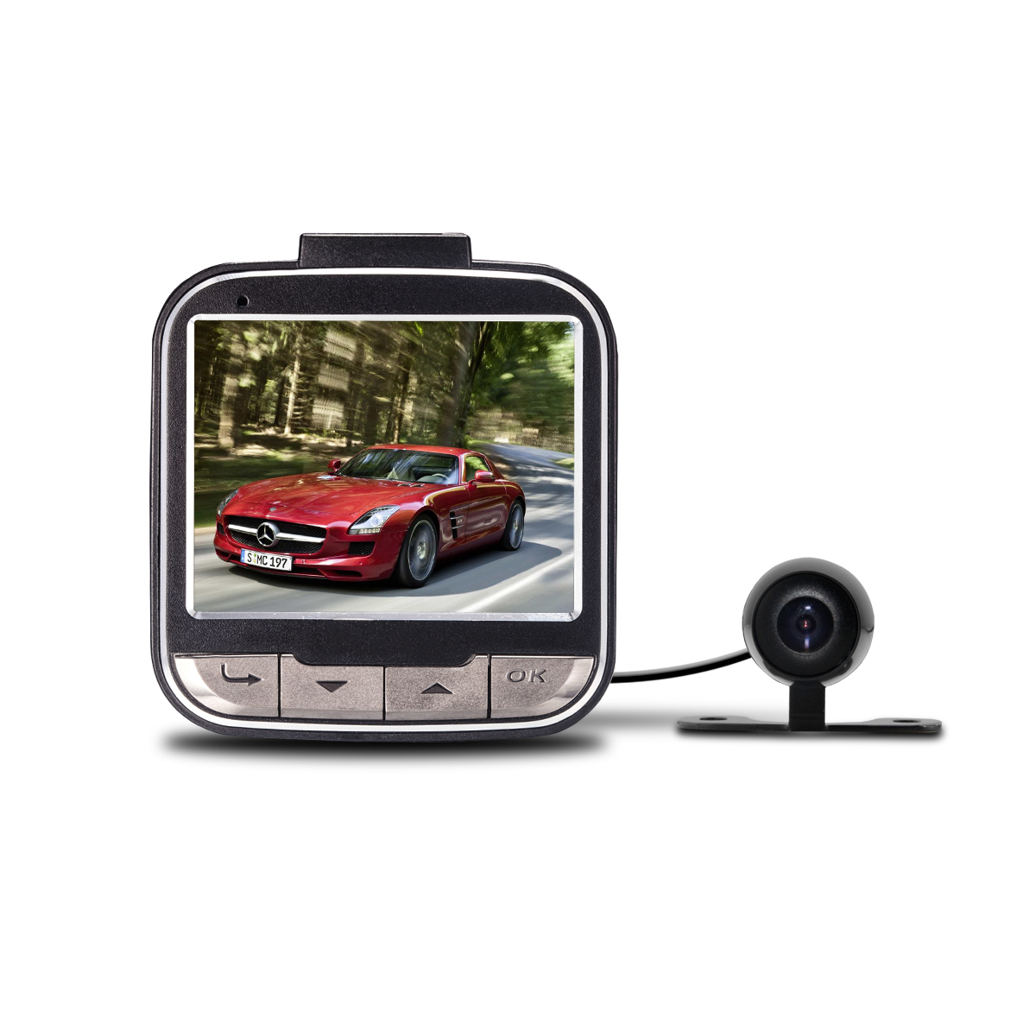
G55B with the best F20 chipset from AllWinner . This model comes with two cameras : one camera is built-in, and another camera is external. The wire of external Camer is about 5 meters for easy installation anywhere in the car. These two cameras can record at the same time, and display in a “PIP”(Picture in Picture) mode on the screen.
This Cam is great aid for driving and proves their worth in many different situations. They could record your memorable precious moments of your life and those recorded videos could also prove great evidence for some undesirable happenings .This camera records in a continuous loop so you could never miss a thing but the G-Sensor helps this device to save those important files from being overwritten which has recorded some important information and this Car DVR always protecting you when driving anywhere at anytime.
This little device gives you big peace of mind and security of your Car.

Main Features:
140 degree wide angle lens
G-sensor function
Motion detection function
Support TF memory card, up to 32GB (Card NOT Included)
Seamless loop-cycle recording function
Automatically turn on/off function
PIP Function
Two camera can record at the same time

Specifications
Chipset | Allwinner F20
Display | 2.0 inch
Sensor | 1.3M CMOS Sensor
Color | Black
Lens Angle | 140 degree wide angle lens
Decode Format | H.264
Video Resolution | Main camera:720P/VGA  Extra camera:720*480
Video Format | MOV
Photo Resolution | 1M/2M/3M
Photo Format | JPG
G-Sensor | YES
Screen Resolution | 960*240
Loop-cycle recording | Off/1min/2min/5min
White balance | Auto//Fluorescent/Tungsten/Cloudy/Sunny
Exposure | -3/-2/-1/0/1/2/3
Frequency | 50HZ/60HZ
TV mode | PAL/NTSC
Language | Simplified Chinese/Traditional Chinese/English/Deutsch/French/Portuguese/  Korean/Italian/Russian/Janpanese
Motion Detection | YES
Shutdown time | OFF/1min/3min/5min
Delay Shutdown | 15sec/1min/5min/30min/OFF
Microphone | YES
Storage Expansion | TF Card(up to 32G)
Battery | 3.7V/150mAH Battery

